Palmer Public School

|  |  |  |  |
| --- | --- | --- | --- |
| Dr. Joel Bohlken, Superintendent | PO Box 248, Palmer, Nebraska 68864 |  | **Board of Education** |
| Sherise Loeffelbein, PK-6 Principal | Phone 308-894-3065 |  | Kathy Wolfe, President |
| Greg Morris, 7-12 Principal |  |  | Todd Weller, Vice President |
| Rob Wegner, Activities Director |  |  | Dana Samuelson, Treasurer |
|  |  |  | Barb Larson, Secretary |
|  |  |  | Jennifer Kunze |
|  |  |  | Ashley Wissing |

**2016 Report to the Public**

Following are some statistics and information about Palmer Public School. This report to the public is outlined in district policy and its content is prescribed in Title 92, Nebraska Administrative Code, Chapter 10 (Rule 10); *Nebraska Rules and Regulations* governing the operation of schools. Much of the information contained relates to the 2015-16 School Year with information regarding prior years for purposes of comparison.

**Enrollment History**

With regard to school finance, no factor applies greater influence than student enrollment, affecting state aid, per-pupil expenditure statistics, and staffing determinations. The chart below shows numbers of Resident students and Option students enrolled at Palmer, K-12, over the past 10 years. The enrollment count of total students has fluctuated moderately during the past ten years with the overall trend being slightly upward, 1.2% per year.

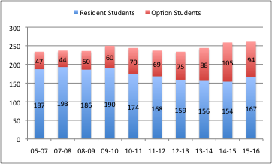During the ten-year period portrayed in the chart, the enrollment count of resident students has decreased by 10% while the option student enrollment count has doubled, resulting in an overall increase in enrollment of over 11%. The **percentage** of the total student population who are Enrollment Option students has nearly doubled during this time period from 20% in 2006 to 36% in 2015. The increase of Option Enrollment students has mitigated what would otherwise be a significant overall decrease in student enrollment. While districts of comparable size and makeup have endured large decreases in enrollment, Palmer Public School has maintained its overall student enrollment the past several years.

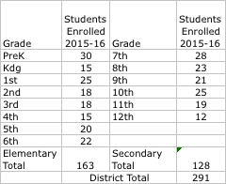

**Enrollment**

The table on the right shows the enrollment by grade for the 2015-16 school year. In grades K-12, there are an average of 20.1 students per grade. With two class sections of preschool and two sections of 1st grade, the average class size in the elementary is 16.3 students. Including paraprofessionals, there are 11.6 elementary students per staff member. Palmer’s low student to teacher ratio allows us to provide every student with individualized attention and support.

**Demographic Comparisons**

|  |  |  |
| --- | --- | --- |
|  | Nebraska | Palmer |
| Free/Reduced Lunch | 44.12% | 45.02% |
| English Language Learners | 6.09% | 0.00% |
| Special Education Percentage | 14.71% | 13.79% |
| School Mobility Rate (14-15) | 12.25% | 13.13% |
| Highly Mobile Students (14-15) | 4.36% | 6.07% |
| Graduation Rate | 89.27% | 92.31% |
| Attendance Rate | 94.89% | 96.22% |
| Dropout Rate | 1.2% | 0% |

The table on the left compares Palmer to the State on several demographic points. Palmer’s rate for students receiving free/reduced lunch and special education remain near the state average. English Language Learners (ELL) are students whose first language is not English. This demographic has increased statewide. Although Palmer has students who speak more than one language, there are not currently any students who are officially classified as ELL.

Any student who enrolls in two or more public schools during an academic year will be considered a highly mobile student. Any child who enters or leaves school between the last Friday in September and the last day of school is counted in the mobility rate. An individual child is counted only once and is divided by the K-12 Fall Membership count taken the last Friday in September. Example: A school building begins the year with 20 students. During the year three students move out and three students move in. The mobility number is six. Example: A school building begins the year with 25 students. During the year five students move out, but one of them returns. The mobility number is five. Palmer had a slightly higher rate of students moving in and out during the 2014-2015 school year than the state average.

Graduation rates are calculated on a cohort basis, which is calculated by dividing the number of students entering 9th grade by the number of students who graduate within four years (8 semesters). Again, Palmer regularly exceeds the state average in this category, even though having small class sizes means one student could significantly decrease the figure.

Palmer’s attendance rate is consistently better than the state average. This is due largely to parental support. School attendance is one of the most important variables in a student’s success. This can also effect funding, because a large difference between Average Daily Membership and Average Daily Attendance can adversely affect state aid.

The dropout rate is calculated by dividing the total number of 7th-12th grade students who dropped out by the official fall enrollment for grades 7-12. Palmer has rarely had a student included in this statistic.

**Student Academic Performance**

Much of the testing information that follows can be found for Palmer Public Schools, and for any school in the state, at <http://www.education.ne.gov/>.

**ACT Test Results**: The graph at right shows a five-year average performance history for Palmer Seniors on the ACT with comparative data for the entire state. The ACT is a curriculum-based achievement test made up of four separate exams in English, reading, mathematics and science. It is scored on a scale of 1 to 36, with 36 being the highest possible score. ACT scores are accepted at virtually all colleges and universities across the nation. The test is administered in all 50 states and was taken by 64% of students in the U.S. graduating class of 2016.

**NAI Test Results**: Nebraska school districts are required to administer a nationally standardized test to students in one elementary grade (2-5), one middle school grade (6-8), and one grade in the high school. Districts may select the grade level assessed and the national achievement test used.

The table below shows 2014-15 data from the Northwest Evaluation Assessment Measures of Academic Progress (NWEA/MAP) test. Results portrayed are the average student scores on this National Assessment Instrument (NAI).

2014-15 NWEA Average Student Scores  
Composite Percent Score (0-100%)

|  |  |  |  |  |
| --- | --- | --- | --- | --- |
|  | **District** | | **State** | |
|  | **Reading** | **Math** | **Reading** | **Math** |
| [Grade 04](javascript:__doPostBack('ctl00$MainContent$gv_NST','Link$0')) | 50% | 58% | 58% | 57% |
| [Grade 08](javascript:__doPostBack('ctl00$MainContent$gv_NST','Link$1')) | 48% | 50% | 56% | 55% |
| [Grade 11](javascript:__doPostBack('ctl00$MainContent$gv_NST','Link$2')) | 69% | 68% | 61% | 59% |

**NeSA Test Results:** The data below are from the Nebraska State Accountability (NeSA) tests, which are given in the spring of each year to students in grades 3, 4, 5, 6, 7, 8, and 11. The fact that results can swing so dramatically from one year to the next demonstrates the problem with basing ratings on a once a year test.

The following table shows the “Percent Proficient” each year on NeSA Reading, for students in grades 3, 4, 5, 6, 7, 8, and 11, over three years for 1) All students, 2) Males, 3) Females, 4) Students Eligible for Free and Reduced Meals. Examining the percent of students who scored “proficient” on the NeSA Reading test reveals an upward trend over three consecutive years by all students and by each subgroup.

|  |  |  |  |  |  |  |  |  |
| --- | --- | --- | --- | --- | --- | --- | --- | --- |
| **NeSA Reading Year** | **All Students** | | **Males** | | **Females** | | **Students eligible for free and reduced lunch** | |
| **Palmer** | **Nebraska** | **Palmer** | **Nebraska** | **Palmer** | **Nebraska** | **Palmer** | **Nebraska** |
| 2013-2014 | 66% | 77% | 65% | 75% | 67% | 80% | 43% | 65% |
| 2014-2015 | 68% | 80% | 65% | 77% | 72% | 82% | 57% | 69% |
| 2015-2016 | 73% | 82% | 74% | 80% | 72% | 85% | 65% | 72% |

The same upward trend exists overall for Math over the last three years (table below). On the NeSA Math test, female students outscored males, and, like NeSA Reading, lower income students lagged behind all students. The trend of lower socioeconomic students scoring lower than all students is consistently evident statewide across all subject areas.

|  |  |  |  |  |  |  |  |  |
| --- | --- | --- | --- | --- | --- | --- | --- | --- |
| **NeSA Math Year** | **All Students** | | **Males** | | **Females** | | **Students eligible for free and reduced lunch** | |
| **Palmer** | **Nebraska** | **Palmer** | **Nebraska** | **Palmer** | **Nebraska** | **Palmer** | **Nebraska** |
| 2013-2014 | 66% | 71% | 63% | 71% | 70% | 72% | 49% | 58% |
| 2014-2015 | 68% | 72% | 66% | 71% | 70% | 73% | 65% | 59% |
| 2015-2016 | 71% | 73% | 64% | 72% | 80% | 73% | 66% | 59% |

The NeSA Science tests are given only to students in grades 5, 8, and 11. Like Reading and Math, Science scores have trended upward over the last three years. Palmer exceeded the state average for percent of all students proficient on the NeSA Science tests.

|  |  |  |  |  |  |  |  |  |
| --- | --- | --- | --- | --- | --- | --- | --- | --- |
| **NeSA Science Year** | **All Students** | | **Males** | | **Females** | | **Students eligible for free and reduced lunch** | |
| **Palmer** | **Nebraska** | **Palmer** | **Nebraska** | **Palmer** | **Nebraska** | **Palmer** | **Nebraska** |
| 2013-2014 | 68% | 72% | 69% | 74% | 68% | 71% | 50% | 56% |
| 2014-2015 | 57% | 72% | 67% | 73% | 48% | 71% | 47% | 56% |
| 2015-2016 | 74% | 72% | 78% | 73% | 67% | 71% | 66% | 56% |

The NeSA Writing tests are given only to students in grades 4, 8, and 11. While Palmer male students exceeded the state average for males, they were significantly lower than Palmer female students. Palmer also exceeded the state average for percent of all students proficient on the NeSA Writing tests. The NeSA writing results across the state were not counted in 2013-14 due to technical problems. The improvement of writing in all curricular areas is our School Improvement Goal.

|  |  |  |  |  |  |  |  |  |
| --- | --- | --- | --- | --- | --- | --- | --- | --- |
| **NeSA Writing Year** | **All Students** | | **Males** | | **Females** | | **Students eligible for free and reduced lunch** | |
| **Palmer** | **Nebraska** | **Palmer** | **Nebraska** | **Palmer** | **Nebraska** | **Palmer** | **Nebraska** |
| 2013-2014 | NA | NA | NA | NA | NA | NA | NA | NA |
| 2014-2015 | 75% | 72% | 63% | 65% | 90% | 80% | 65% | 59% |
| 2015-2016 | 74% | 71% | 67% | 63% | 83% | 79% | 64% | 58% |

**AQuESTT Ratings:** Beginning with the 2014-15 school year, the State Board of Education and the Nebraska Department of Education used a new accountability system. The new state system — Accountability for a Quality Education System, Today and Tomorrow (AQuESTT) – classifies schools and districts on state test scores, graduation rates, student participation rates as well as year-to-year improvement and growth.

A school’s “Raw Classification Status” is calculated by averaging the NeSA assessment scores across all available grade levels and subjects. This average is used to classify districts and schools into four rating levels: Excellent (4), Great (3), Good (2), or Needs Improvement (1).

**AQESTT Rating - High School**

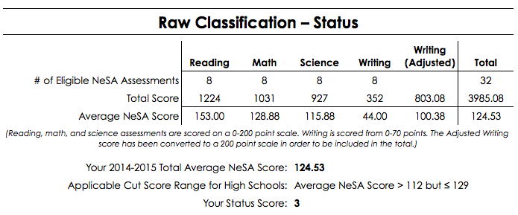

A school’s Status Score can be adjusted up or down depending on a number of other factors. “Non-Proficiency” is one of the factors, and is based on the percentage of NeSA assessment scores at the school/district that were rated as Non-Proficient over the last three years. If there is an upward trend of a certain amount (more Non-Proficient scores) then the raw classification will be decreased by one level, while if there is a downward trend of a certain amount (less Non-Proficient scores) then the raw classification will be increased by one level. For Palmer High School, the Status Score was adjusted up from a “3” to a “4” based on our “Non-Proficiency Trend” (table on next page).

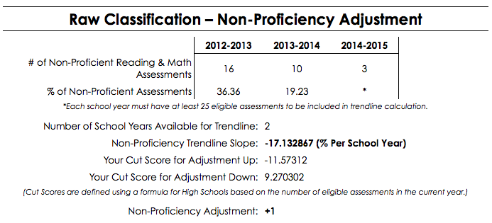

**AQUESST Rating – Middle School**

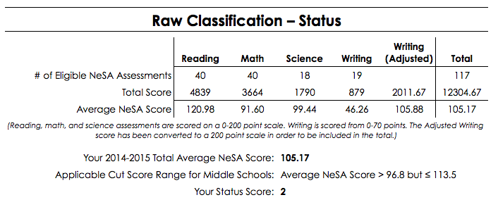

**AQUESTT Rating – Elementary**

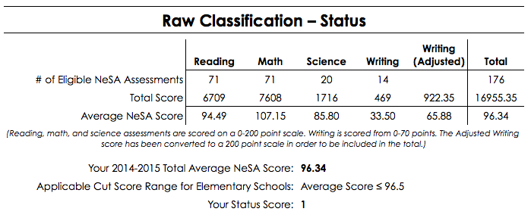

**Faculty and Staff**

The table below shows the Full Time Equivalency (FTE) count of teachers for Palmer Public Schools over the past three years. In 2014-15, Palmer added two teachers to accommodate growing student enrollment, one in the elementary and one in the secondary.

|  |  |  |  |  |  |  |
| --- | --- | --- | --- | --- | --- | --- |
|  | Total Teacher Count | | Total Teachers with Master's Degrees | | Percentage of Teachers with Master's Degrees | |
| Years | State | Palmer | State | Palmer | State | Palmer |
| 2013-2014 | 22,302 | 21.36 | 11,878 | 9 | 51.73% | 37.50% |
| 2014-2015 | 22,702 | 23.24 | 12,146 | 7 | 52.16% | 26.92% |
| 2015-2016 | 23,002 | 23.24 | 12,491 | 7 | 53.07% | 26.92% |

|  |  |  |  |  |
| --- | --- | --- | --- | --- |
|  | Average Years Experience | | Average Teacher Salary | |
| Years | State | Palmer | State | Palmer |
| 2013-14 | 14.56 | 10.13 | $49,669 | $39,338 |
| 2014-15 | 14.34 | 10.04 | $50,681 | $40,364 |
| 2015-16 | 14.15 | 11.04 | $51,520 | $42,879 |

The table at right shows both Average Years Experience and Average Salary for teachers in Palmer and the state average. Average teacher salaries in comparison to the state change accordingly as Palmer’s average years of experience increases or decreases; and as the percentage of Masters Degrees increases or decreases.

**Finances: General Fund Budget, Tax Levy, Tax Asking**

|  |  |  |  |  |
| --- | --- | --- | --- | --- |
|  | Assessed Valuation | | | |
| County | 2013-14 | 2014-15 | 2015-16 | 2016-17 |
| Howard | $26,696,364 | $33,058,953 | $41,068,975 | $42,974,926 |
| Merrick | $124,811,531 | $154,463,654 | $176,909,767 | $195,378,125 |
| Nance | $48,420,801 | $61,754,016 | $77,527,000 | $82,914,112 |
| Total | $199,928,696 | $249,276,623 | $295,505,742 | $321,267,163 |
| % Increase | 18.20% | 24.68% | 18.54% | 8.71% |

The largest single source of receipts for the District is property tax. The table at right shows the District’s assessed valuation with a breakdown by county over the past four years, during which the annual assessed valuation has averaged 17.5% increase.

|  |  |  |  |  |
| --- | --- | --- | --- | --- |
|  | 2013-14 | 2014-15 | 2015-16 | 2016-17 |
| General Fund | $3,587,400 | $3,919,745 | $4,182,276 | $4,511,500 |
| Cash Reserve | $879,336 | $883,653 | $1,287,995 | $1,544,936 |
| Total Requirement | $4,466,736 | $4,803,398 | $5,470,271 | $6,056,436 |
| Expenditures | $3,181,077 | $3,297,234 | $3,527,795 |  |

The table at rightshows the General Fund budget requirements for the past three fiscal years as well as the current year. The General Fund is the District’s day-to-day operating fund and does not include fiduciary funds such as those used to support activities (Activity Fund) and the Lunch Fund, or the Bond Fund and Special Building Fund. The difference between budgeted amounts and audited expenditures is due to unforeseeable expenses over the course of the budget year and varying needs for transfers from the General Fund and other funds within the General Fund, primarily the Depreciation Fund; reflected as expenditures from the General Fund.

The table below shows the property tax rates, by fund, for the past three fiscal years and for the current year, as well as a calculation of the amount by which each levy changed. Note: Levies are expressed in dollars and cents per $100 of valuation.

|  |  |  |  |  |  |  |  |
| --- | --- | --- | --- | --- | --- | --- | --- |
| **Fiscal Year** | **General Fund Levy** | **Bond Fund Levy** | **Special Building Fund Levy** | **QCPU Fund Levy** | **Total** | **Levy Change** | **Percent Levy Change** |
| 2013-2014 | 0.950096 | 0.061386 | 0.015194 | 0 | 1.026676 | -.000145 | -0.01% |
| 2014-2015 | 0.95 | .0343 | .0257 | 0 | 1.01 | -.016676 | -1.62% |
| 2015-2016 | 0.952 | 0 | 0 | .052 | 1.004 | -.006 | -0.59% |
| 2016-2017 | 0.81681 | 0 | 0 | .052 | 0.86881 | -.13519 | -13.47% |

|  |  |  |  |  |
| --- | --- | --- | --- | --- |
| Tax Asking | 2013-14 | 2014-15 | 2015-16 | 2016-17 |
| Bonds | $122,727 | $85,613 | $153,664 | $167,060 |
| All Other Funds | $1,929,893 | $2,432,080 | $2,813,216 | $2,624,141 |
| Total Asking | $2,052,620 | $2,517,693 | $2,966,880 | $2,791,201 |

The table at right shows the recent history of the tax amounts the district has asked in support of Palmer Public Schools. The “Bonds” amount includes the Bond Fund asking as well as the Qualified Capital Purpose Undertaking Fund (QCPUF) asking.

The District’s State Aid over the last four years is presented below. As the table indicates, state aid to Palmer Public Schools has decreased significantly. This can be attributed to state budget cuts, and increases in property valuations, which increased the amount of local resources calculated in the state aid formula.

|  |  |  |  |
| --- | --- | --- | --- |
| **Fiscal Year** | **State Aid** | **Difference** | **% Change from previous** |
| 2013-2014 | $1,036,789 | $31,069 | 3.08% |
| 2014-2015 | $1,091,861 | $55,072 | 5.31% |
| 2015-2016 | $867,375 | -$224,486 | -20.56% |
| 2016-2017 | $857,588 | -$9,787 | -1.13% |

During the 4-year period portrayed, State Aid decreased by a total of $179,201; a decline of just over 17%. In 2015-16, the district became a “Non-equalized” district, meaning we receive no State Aid for equalization. The district currently receives state aid only for option enrollment students and the income tax rebate.

While total state aid has decreased, the cost of education increased. Some of this cost is due to increased personnel costs but costs associated with increased data tracking and reporting requirements cannot be overlooked.

|  |  |  |  |  |
| --- | --- | --- | --- | --- |
| **FSY 2012-13** | |  | **FSY 2015-16** | |
| % Total | Receipted | Funding Source | Receipted | % Total |
| 53.55% | $1,611,368 | Local Sources | $2,644,299 | 64.38% |
| 0.50% | $15,031 | County/ESU Sources | $11,608 | 0.28% |
| 41.18% | $1,239,077 | State Sources | $1,323,329 | 32.22% |
| 4.75% | $142,860 | Federal Sources | $123,748 | 3.01% |
| 0.03% | $838 | Non Revenue | $4,421 | 0.11% |
| Total | $3,009,174 | Total Receipts | $4,107,405 | Total |

In comparing 2013 receipts to 2016 receipts, we see the level of support from the county, state, and federal levels has all decreased substantially. However, the cost associated with the federal and state requirements for data tracking, assessment, and reporting has increased. The local sources have necessarily increased to make up the difference in funding. Palmer Public Schools has attempted to build reserves in anticipation of continued decreases in both State and Federal funding.

|  |  |  |
| --- | --- | --- |
| School System | Formula Student Count | GFOE per Formula Student |
| DILLER-ODELL | 254.03 | 14,066.42 |
| WEST BOYD | 255.23 | 11,982.55 |
| ANSELMO-MERNA | 255.32 | 13,006.42 |
| GARDEN COUNTY | 256.19 | 12,508.28 |
| HUMPHREY | 258.39 | 11,641.98 |
| HARVARD | 264.78 | 13,362.34 |
| PALMER | 265.14 | 10,478.95 |
| EMERSON-HUBBARD | 268.50 | 14,112.88 |
| PAWNEE CITY | 273.63 | 12,895.76 |
| FRANKLIN | 276.26 | 14,484.12 |
| MCCOOL JUNCTION | 276.58 | 11,289.42 |
| HITCHCOCK COUNTY | 277.97 | 11,022.62 |
| EAST BUTLER | 278.68 | 17,920.48 |

Per pupil expenditures (PPE) can be affected by a number of factors including fluctuations in enrollment and General Fund expenditures as well as depreciation on the building and equipment in addition to transfers to the Depreciation Fund. Palmer’s overall PPE consistently remains near the statewide average and below that for schools of comparable size. Per Pupil Expenditure varies only slightly from “General Fund Operating Expenditures per Formula Student,” a critical component in the State Aid funding formula. The GFOE for the next six larger and next six smaller schools in the state for 2015-16 are portrayed above. Unique circumstances (poverty, transportation needs, Special Education…) can have a dramatic affect on a district’s budget and should be considered in comparing such data.

The total assets for the funds used by Palmer Public Schools for the past three years are portrayed below. As noted previously in the receipts table, Palmer Public Schools has attempted to build reserves in anticipation of continued funding cuts from other sources and the data below indicate that this effort has been somewhat successful.

|  |  |  |  |
| --- | --- | --- | --- |
| **Fiscal Year** | **Governmental Funds** | **Fiduciary Funds** | **All Funds** |
| 2013-2014 | $1,913,715 | $98,324 | $2,012,039 |
| 2014-2015 | $3,213,358 | $103,424 | $3,316,782 |
| 2015-2016 | $3,341,607 | $109,499 | $3,451,106 |

*Governmental Funds=Total Assets of The General Fund, Depreciation Fund, Employee Benefit Fund, Bond Fund, Special Building Fund and The Qualified Capital Purpose Undertaking Fund, School Nutrition Fund, Cooperative Fund*

*Fiduciary Funds=Activities Fund, Scholarship Fund and Memorial Fund*